**Supporting Documentation: Task 2 and 3**

**Student: Úna McGinn**

**CA675 Assignment 1**

Following trial and error in an attempt to obtain the top close to 50,000 records, the following query was tried.

select top 50000 * from posts where posts.ViewCount > 129462

ORDER BY posts.ViewCount

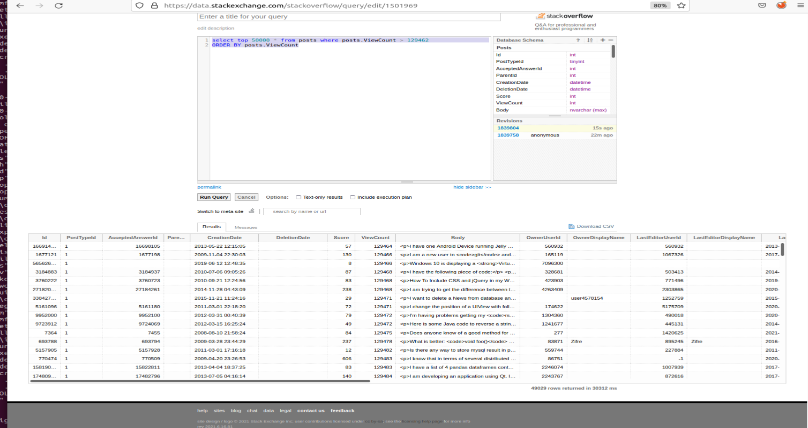

From the above, I can see that the lowest ViewCount in the dataset is 129464. Therefore, for the 1st dataset I will select the records with Viewcount > 129464 to remove the need to account for the possibility that there may be multiple videos with 129464 views.

**Dataset Part 1:**

select top 50000 * from posts where posts.ViewCount > 129464

ORDER BY posts.ViewCount

Result: 49028 rows

**Dataset Part 2:**

select top 50000 * from posts where posts.ViewCount <= 129464 and posts.ViewCount > 77000

ORDER BY posts.ViewCount

Result: 47385 rows

From the above, I can see that the lowest ViewCount in the dataset is 77001. There are less than 50,000 records in the dataset so all values in this range are in the dataset.

**Dataset Part 3:**

select top 50000 * from posts where posts.ViewCount <= 77000 and posts.ViewCount > 55500

ORDER BY posts.ViewCount

Result: 46963 rows

**Dataset Part 4:**

select top 50000 * from posts where posts.ViewCount <= 55500 and posts.ViewCount > 43000

ORDER BY posts.ViewCount

Result: 48499 rows

**Dataset Part 5:**

Tried the following: select top 8125 * from posts where posts.ViewCount <= 43000 and posts.ViewCount > 35000

ORDER BY posts.ViewCount

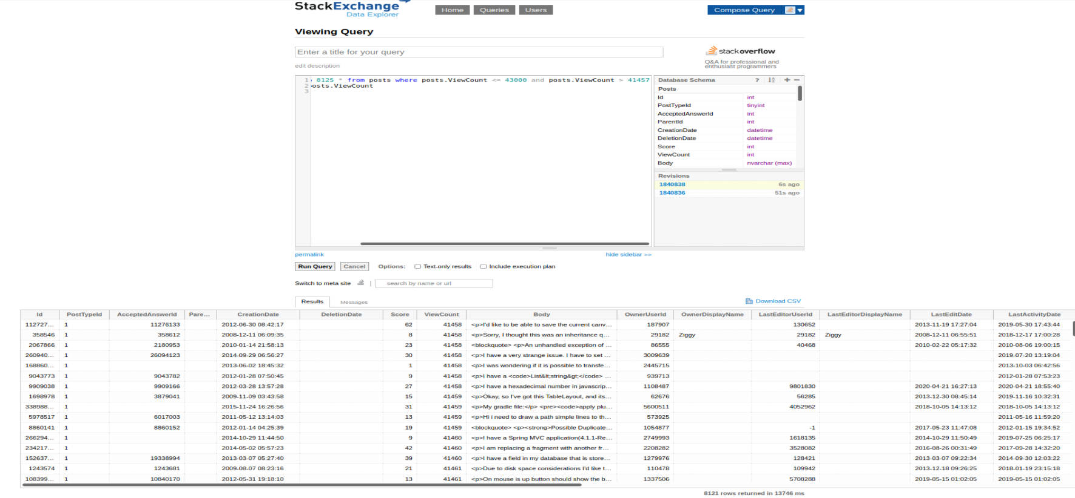

By trial and error, used the following interval to obtain the next 8125 records.

select top 8125 * from posts where posts.ViewCount <= 43000 and posts.ViewCount > 41457

ORDER BY posts.ViewCount

Result: 8125 rows

For the final subset I take the top 8125 records i.e.(the number of records required to make up 200,000 records). These 5 batches have 49028, 47385, 46963, 48499 and 8125 records respectively, making up the total dataset of 200,000.